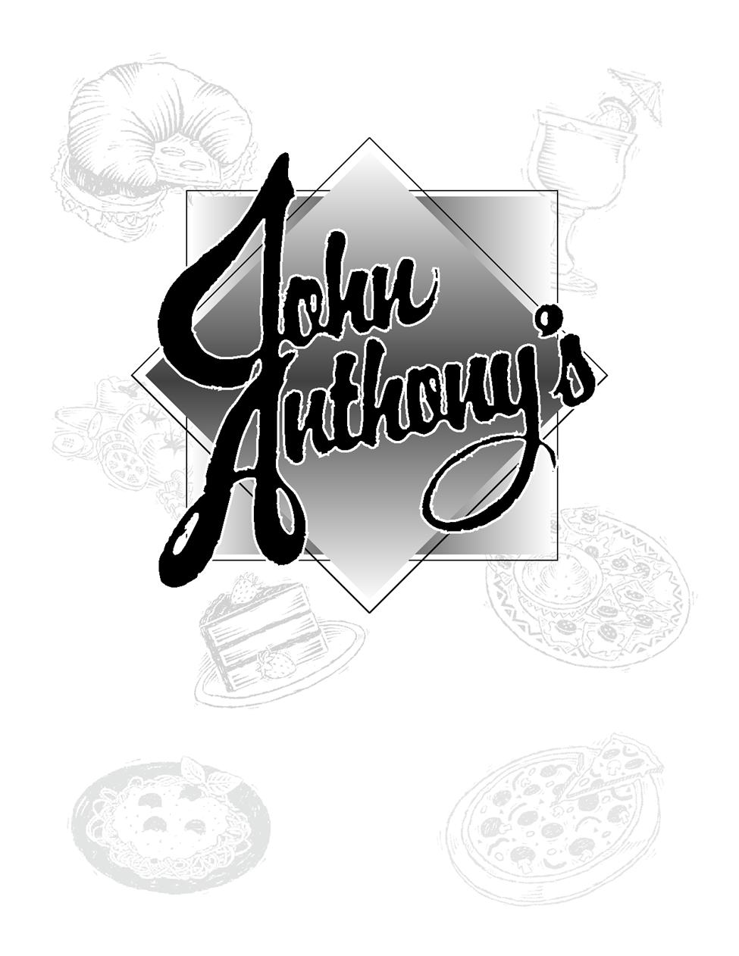
Serving Fine Italian Food since 1985
412-795-8666 • 115 Center- New Texas Rd. • Pgh. PA 15239

BURGERS
HAMBURGER $7.50
We use Fiore’s fresh ground meat, 8oz.!
CHEESEBURGER $8
American, Swiss, Provolone, Feta or Blue Cheese
Anthony BURGER $8.50
With Anthony Peppers (hot, sweet and vinaigrette) &
provolone cheese
Bacon CHEESEBURGER $8.50
With American, Swiss or Provolone
Bruschetta BURGER $8.50
Topped with Fresh made bruschetta and provolone

All Burgers and Hoagies served with french fries, onion rings, apple sauce or cole slaw
*Consuming raw or uncooked foods may increase your risk of food bourn illness, especially if you have a medical condition

PIZZA • PIZZA • PIZZA

FRESH DOUGH PIZZA
16” $13 Toppings $2.00
10” $8 Toppings $1.25
TOPPINGS: pepperoni, mushrooms, onions, green peppers, anchovies, jalapeños, bacon, hot sausage, feta,
kalamata olives, Anthony peppers (hot), meatballs, spinach, ham, Extra $$:Feta$3 Artichoke hearts$3 Chicken$4 Shrimp$5

KIDS STUFF

PIZZA BREAD (plain or pepperoni) $4.50
SPAGHETTI & MEATBALL $5.50
CHICKEN PLANKS & FRIES $6
Add Soup or Salad $2 to any “Kids Stuff”

BEVERAGES

COFFEE, HOT TEA, ICED TEA $2
LEMONADE & BOTTLED WATER
SODAS $2
Pepsi, Diet Pepsi, Slice, Mt. Dew,
Raspberry Tea, Root Beer, Ginger Ale & Orange

MILK white $2 chocolate $2.15

FRUIT JUICES $2.25

FROM THE BAR

HOUSE WINES: By the Glass OR 1/2 Carafe
REDS: Merlot, Cabernet Sauvignon, Chianti
Lambrusco, Valpolicella,
WHITES: Chardonnay, Pinot Grigio,
Moscato, Reisling,
BLUSH:White Zinfandel

AMERICAN BEER: Bud, Bud Lite, Bud Lite Lime, Iron City, I.C. Lite, Killians Red, Coors Lite,
Rolling Rock, Straub Lite, Miller, Milller lite, MGD
MGD 64, Michelob, Mich lite, Mich Ultra, Amber Back, Stoneys, Sam Adams Lager and Seasonal Brews, Blue Moon
BAKED HOAGIES
ITALIAN $8.50
Salami, ham, cappicola, provolone, lettuce, tomato,
onion & Italian dressing
SICILIAN CHICKEN $8.50
Grilled sliced chicken topped with Anthony peppers,
Provolone, bruschettta, and lettuce
MEATBALL $8.50
Aunt Carol’s homemade meatballs with provolone cheese
STEAK & CHEESE $9
6oz. Grilled chipped Steak with sautéed mushrooms, onions,
green peppers & provolone cheese
CHICKEN PARM Hoagie $8.50
Breaded, fried and topped with provolone and sauce

White Pizza: 10” $10 16” $15
garlic,olive oil sauce with parmesan cheese, oregano and sliced tomatoes

CHICKEN SALAD planks, cheddar & fries $7
BASKET OF SHRIMP & FRIES $6.50
RAVIOLI (cheese or meat) $6.50

DESSERTS

SUNDAES $4
Hot fudge, Chocolate, Strawberry or Caramel

PECAN BALL $5
Hot fudge, Chocolate, Strawberry or Caramel

ASK SERVER FOR TODAY’S SELECTIONS!

NON-ALCOHOLIC BEER:
Old Milwaukee

IMPORTED BEER: Amstel Lite, Corona, Heineken, Heineken Lite, New Castle, Becks, Guinness

DRAFT BEER: Labatts, Coors Lite, Yuengling,
And a Seasonal Specialty Draft

HOMEMADE SOUPS

SOUP OF THE DAY

French Onion Soup
Cup 3.50 Bowl 4.25

Homemade Soup of the Day
Cup 3.50 Bowl 4.25
Take a Quart of Our Homemade Soup Home: $9.50

Savory Salads

TOSSED SALAD Small $4 Large $6

CHEF SALAD $9
Turkey, Ham, American, Swiss & Egg over tossed salad

ANTIPASTA SALAD $9.50
Provolone, salami, kalamata olives, onions, tomato
pepperoncini & red peppers

Buffalo Shrimp or Chicken Salad $11
Fried chicken or shrimp dipped in hot sauce, served over salad greens topped with bleu cheese and onion rings

HERB GRILLED SHRIMP SALAD $11.50
9 Herb grilled Shrimp, toasted almonds & blue cheese with strawberry vinaigrette dressing
Homemade Dressings: House Dressing - Parmesan Pepper– Bleu Cheese ($extra), Thousand Island,
Sweet & Sour, Honey Mustard, Ranch, Italian, Balsamic Vinaigrette, Strawberry Vinaigrette & Lite Italian

Finger Foods!

FRIED MUSHROOMS hand breaded $6.50
FRIED CAULIFLOWER hand breaded $6.50
ZUCCHINI THINS fresh cut $6.50
PROVOLONE STICKS $6
Hand breaded, served with marinara
BASKET OF ONION RINGS $5
Batter-Dipped
CHICKEN WINGS $8
6 whole jumbo wings blue cheese & celery $.50
FRENCH FRIES Side $2.50 Basket $4
With Nacho cheese $5 3 cheese & bacon $6
COCONUT SHRIMP $8.50
5 hand breaded, fried & served with pina colada sauce

Italian Appetizers

ITALIAN GREENS Escarole in oil & garlic$6.50

with beans $7.50

GREENS TRESCO with grilled chicken $10.50
Tresco with beans $11

HOT STUFFED PEPPERS $7
With sausage & bread stuffing baked in sauce & topped
with melted provolone
BRUSCHETTA $5.50 Italian bread brushed with
Olive oil, topped with tomato, basil, garlic and asiago

Aunt Carol's famous recipe
Wedding Soup Cup 3.50 Bowl 4.25

GRILLED CHICKEN SALAD $10
Grilled chicken breast over tossed salad, topped with fries
(cheddar, feta or provolone cheese at your request)

Calabrese STYLE CHICKEN SALAD $10.50
Grilled chicken breast over tossed salad and topped with sautéed mushrooms, onion, green peppers, cheddar cheese & french fries

GRILLED STEAK SALAD $11.50
6oz. grilled Strip Steak over tossed salad, topped with fries (cheddar, feta or provolone cheese at your request)

Calabrese STYLE STEAK SALAD $12
6oz. grilled Strip Steak over tossed salad, topped with sautéed mushrooms, onion, green peppers, cheddar cheese & fries

BASKET OF SHRIMP 9 fresh breaded $7.50

BUFFALO SHRIMP $8
Dipped in Buffalo sauce, served with blue cheese & celery

POTATO SKINS $6.50
Filled with cheese and bacon bits, served with sour cream

CHEESE NACHOS $6
Served with spicy nacho cheese, jalapenos, and salsa

CHICKEN PLANKS $7

BUFFALO CHICKEN PLANKS $7.50
Dipped in Buffalo sauce, served with blue cheese & celery

SIDE DISHES

MEATBALLS $3
2 homemade Meatballs topped with melted provolone
SIDE OF SPAGHETTI $3.50
BAKED POTATO $3
APPLE SAUCE $2 COLE SLAW $2
VEGETABLE $2.50

SANDWICHES

CLUB SANDWICH $8.50
Turkey breast, ham, bacon, American cheese,
Lettuce and tomato on wheat or white toast
GRILLED CHEESE $7

TURKEY REUBEN $8.50
Grilled turkey, swiss, slaw & thousand island dressing on rye

REUBEN $9.50
Grilled corned beef with sauerkraut, swiss cheese
and thousand island dressing on grilled rye bread
All sandwiches served with french fries, onion rings, coleslaw or applesauce
Dare To Be Different!

JOHN D SPECIAL $9.50
Fried eggplant & chicken tenders stacked with sauce & provolone cheese, topped with our spicy hot Anthony peppers!

FAJITA WRAP Chicken or Cod $9.50 Steak $10.50
Marinated steak, chicken or Cajun scrod wrapped in a flour tortilla with grilled peppers & onions, cheddar cheese & lettuce served with sour cream & salsa

HERB GRILLED CHICKEN $9
Served on toasted ciabatta bread with roasted red pepper, provolone cheese, lettuce, tomato & balsamic vinaigrette
All sandwiches served with french fries, onion rings, coleslaw or applesauce
Irresistibly Italian

LASAGNA homemade 4 cheese $13
RAVIOLI cheese $14 or meat $15
Spaghetti & Meatballs $11
GNOCCHI $12.50
Linguini with Garlic butter $10
Add sautéed Chicken $4 or Shrimp $5
Linguini with Spinach Aioli $11.50
sautéed fresh baby spinach in garlic & olive oil
Above entrees served with Soup or salad.

AMERICAN FAVORITES

N.Y. STRIP STEAK $18
Fresh hand cut, 12oz., char grilled

CHICKEN MARSALA $14
Sautéed chicken with mushrooms in Marsala wine sauce

CHICKEN ANTHONY $14
Boneless breast sautéed with hot peppers, sweet
peppers & mushrooms in oil & garlic

BAKED FISH $14.50
Baked Cod fillet in a garlic butter & wine sauce

DEEP FRIED FISH $14.50
Fresh breaded Cod

Above entrees served with choice of two: soup, salad, pasta, baked potato,
applesauce, vegetable or french fries.

HOT SAUSAGE SANDWICH $8.50
Hot Italian sausage with sauce, onion & green pepper
FISH SANDWICH $9.50
Fresh hand breaded, fried Cod, served on a kaiser bun.

CHICKEN SANDWICH $8.50

Grilled, Breaded or Cajun Grilled

HOT ROAST BEEF SANDWICH $8.50
Served with french fries & gravy

GRILLED HAM & CHEESE $8

TURKEY WRAP $9
Grilled Turkey, blue cheese, walnuts, chopped lettuce & tomato rolled in a flour tortilla with balsamic vinaigrette on the side

EGGPLANT SANDWICH $8.50
Topped with marinara sauce and melted provolone cheese

PORTABELLA BURGER $8.50
Marinated, grilled Portabella cap with roasted red pepper, feta, provolone, lettuce and pesto mayo on ciabatta bread

Linguini Alfredo $12 Add grilled chicken $4 or Shrimp $5
Meatballs Parmesan with side of pasta $13.50
Veal Parmesan with side of pasta $16
Eggplant Parmesan with side of pasta $14
Chicken Parmesan with side of pasta $14

JOHN D. SPECIAL with side of pasta $16.50
Eggplant & chicken parmesan layered with sauce,
Anthony peppers (hot & sweet) & melted provolone cheese

SHRIMP SCAMPI $16
7 Fresh shrimp sautéed in garlic butter & wine sauce

DEEP FRIED SHRIMP $15
6 Fresh breaded shrimp

VEAL MARSALA $16
Tender veal & mushrooms in Marsala wine sauce

VEAL ANTHONY $16
Tender veal sautéed with hot peppers, sweet peppers & mushrooms in oil & garlic

VEAL FLORENTINE $16
Pounded veal cutlet lightly breaded, pan sautéed and topped with sautéed baby spinach and provolone, served over marinara

